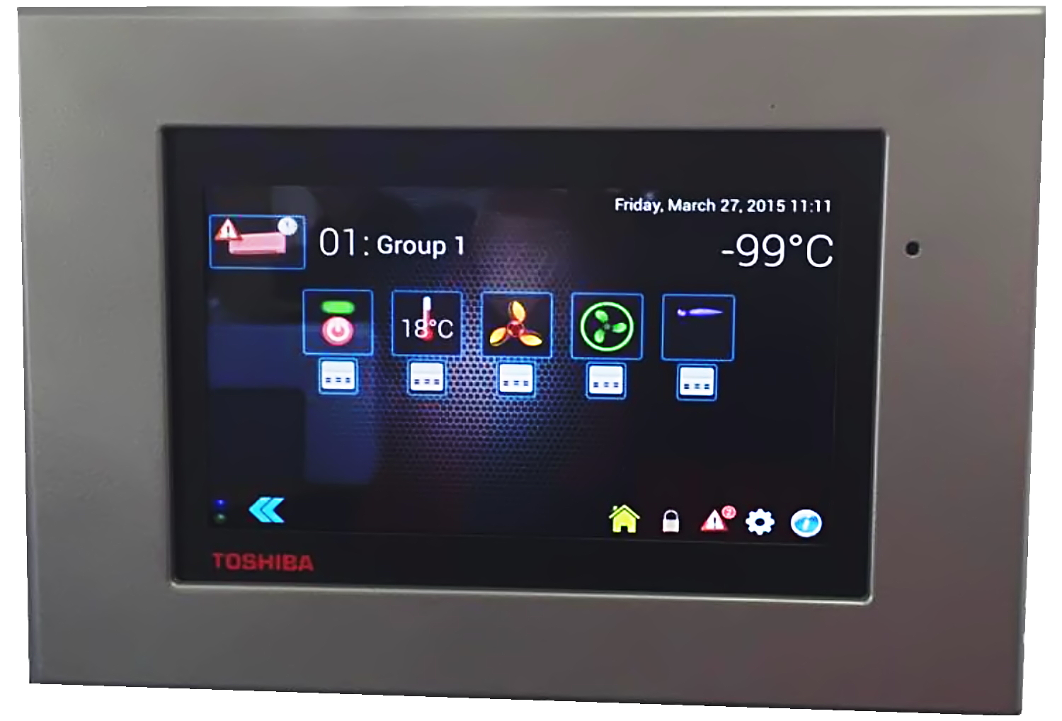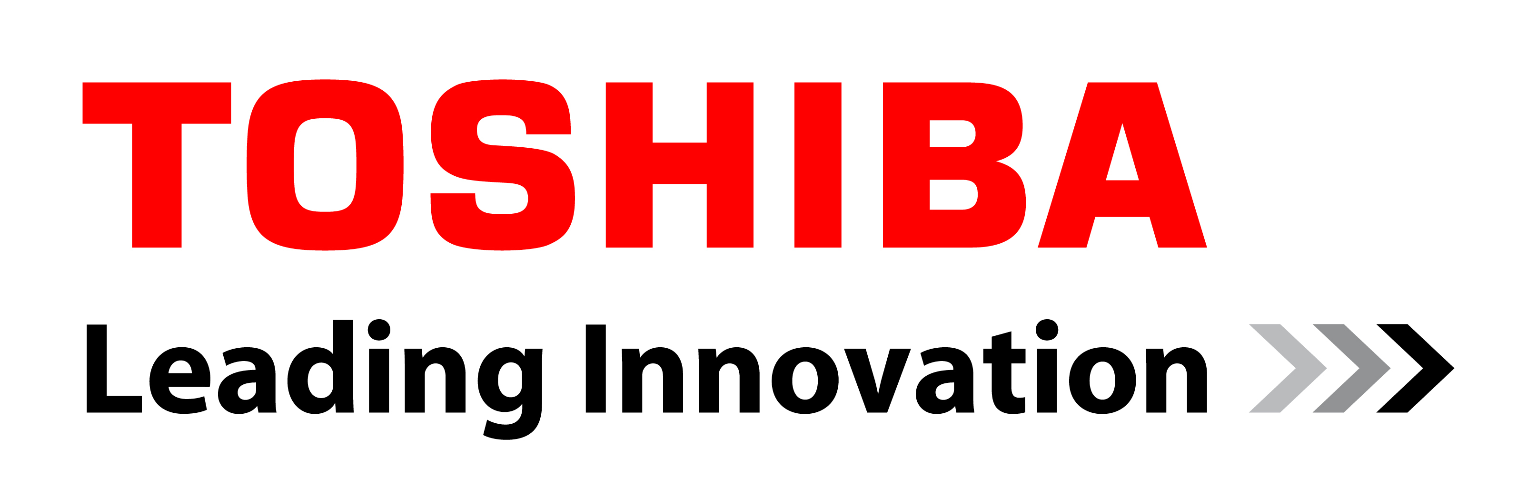
Cooling Post Reader Competition

Win a sparkling new Toshiba
touchscreen air conditioning controller!
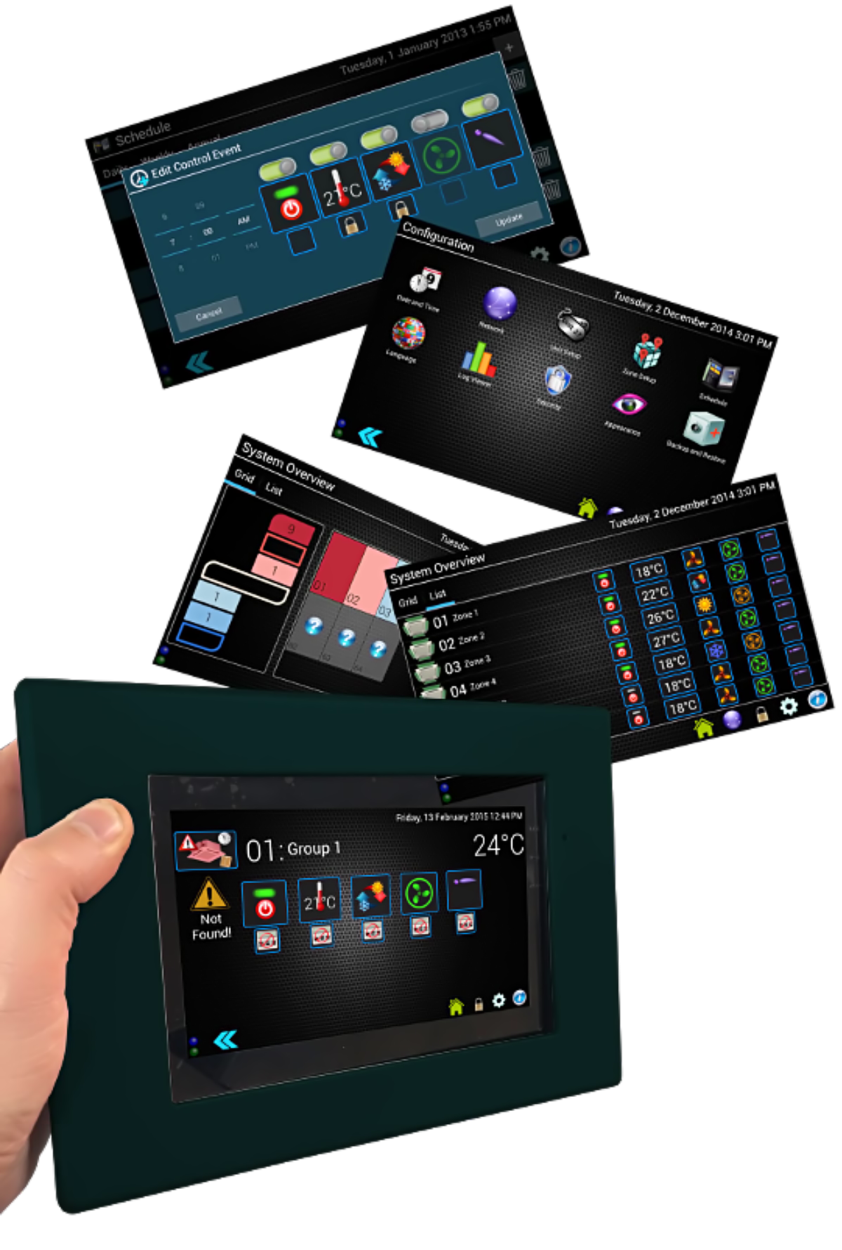
Readers of Cooling Post can win one of five state-of-the-art Toshiba touchscreen air conditioning controllers, each with a list price of £2220.00

How to enter
Just answer the following Toshiba-flavoured questions, fill in the tie-breaker and email to: marketing.uk@toshiba-ac.com

Q1. How many hands-on air conditioning training centres can Toshiba and our distributors offer training at?
A = 3
B = 8
C = 13

Q2. Toshiba are sponsors of what major sporting event in 2015?

A = Rugby World Cup
B = Winter Olympics
C = Wimbledon

Q3. Which of Toshiba’s award winning leak detection and containment systems allows the isolation of a single room whilst keeping the rest of the system operational?

A = RBC-RD3
B = RBC-RD7
C = RBC-AIP1

Q4. Toshiba are the only manufacturer to offer what support service?
A = Software Tools
B = Design Assistance
C = 24/7/364 technical helpline.

Q5. What is the name of Toshiba’s unique warranty offering?

A = Total Peace of Mind
B = Warranty Express
C = Limited Warranty

Q6. What state-of-the-art screen is used on the Toshiba touch screen?

A = Resistive
B = Capacitive

Tie Breaker question:
What name would you give to this new-state-of-the-art Toshiba touch screen controller?

………………………………………………………………………………………………

Name
………………………………………………………………………………………………

Company
………………………………………………………………………………………………

Address
………………………………………………………………………………………………

………………………………………………………………………………………………

………………………………………………………………………………………………

………………………………………………………………………………………………

Tel …………………………………………
Mob …………………………………………
Email …………………………………………

What to do now
Please email your completed form to us at: marketing.uk@toshiba-ac.com
The deadline for entries is 5pm on 15 June 2015. Winners will be notified by 1 July 2015.

Rules
Toshiba UK Touch Screen Controller Competition
To kick-start the launch of our new Touch Screen Controller Toshiba Air Conditioning (a division of Toshiba Carrier UK Limited) will be running a competition based on knowledge of Toshiba UK and our products – the Toshiba Touch Screen Competition (“TTSC”) – whereby you could win one of five state of the art Touch Screen Controllers for correctly answering the ten multiple choice questions and then providing the best tie breaker response and help name this new controller. .

This Competition is open to employees of companies who purchase and/or specify Toshiba Air Conditioning equipment (e.g. consultants, contractors and end users). To enter the competition, simply answer correctly the product knowledge questions on the entry form. Terms and Conditions apply.

How to Play
The format of the competition is simple: all you need to do is answer all six questions correctly.

All correctly answered entries will be judged on the tie breaker answer to pick the overall five winners of the competition. All entrants must complete the tie breaker question to gain entry in to the Competition. The most original, interesting and professional tie breaker response will be chosen from the all correct entries.

TERMS & CONDITIONS
- Toshiba Carrier (UK) Ltd (“TCUK”), registered at Porsham Close, Belliver Industrial Estate, Roborough, Plymouth, Devon, PL6 7DB has devised a competition (the “Competition”) for eligible entrants to win one of the prizes described below.
- These terms and conditions apply to the Competition and by entering the Competition all entrants agree to be bound by these terms and conditions.
- In the event of any dispute in relation to these terms and conditions, the conduct, the result and all other matters relating to the Competition, the decision of TCUK shall be final and no correspondence shall be entered into.
PRIZES
Star Prize
- Star Prize – the five entrants who have answered all six questions correctly and have provided the most original, interesting and professional response to the tie breaker question , will each be eligible to win one of five Touch Screen Controllers. The judges’ decision on the winning entries will be final and no correspondence will be entered into.
ELIGIBLE ENTRANTS
- This Competition is open to employees of companies who purchase and/or specify Toshiba air conditioning equipment (consultants, contractors and end users).
- More than one person may enter the Competition from any one company, however only one entry is permitted per person. No purchase is necessary.
- All entrants in the Competition must be aged 18 years or older and must be resident in the United Kingdom or the Republic of Ireland.
- No employees of TCUK nor anyone connected with setting up, administering or judging the Competition will be eligible to enter the Competition.
- TCUK reserves the right to disqualify any participant if it has reasonable grounds to believe such participant has breached any of these terms and conditions.
HOW TO ENTER
- To enter the Competition, eligible participants must submit their fully-completed entry on the Toshiba Touch Screen Controller Entry Form 2015 (to include full name, daytime telephone number, name of employer, postal address, email address and completed tie-breaker question) by email to marketing.uk@toshiba-ac.com by no later than 5.00pm GMT on 15 June 2015. Any entry submitted after such time will not be accepted.
- The first entry submitted by each entrant will be final.
- No entry can be reversed once submitted. No allowances will be considered.
- TCUK shall not be liable for any defect of receipt of entries and takes no responsibility for entries that are lost, delayed, illegible, corrupted, damaged, incomplete or otherwise invalid.
- Any validations based on time will be determined by the SERVER timestamp. Although the time is frequently checked, it is up to you to ensure your entry is submitted to marketing.uk@toshiba-ac.com within the given time period detailed in paragraph 10 above.
PUBLICITY AND DATA PROTECTION
- By entering the Competition, all entrants irrevocably authorise TCUK to publicise any information supplied by them including but not limited to their answers, the Tie breaker responses, their name, location, company name and/or business address and such information may be used for publicity announcements or marketing initiatives by TCUK in any and all media. Entrants will retain copyright of their submitted entries, however by entering the Competition, all entrants grant TCUK a worldwide royalty-free perpetual licence to edit, publish and use each entry in any and all media for publicity purposes.
- The prize winners agree to the use of their photographs and/or audio and/or visual recordings of them in any publicity and that such use shall not give rise to any form of compensation whatsoever.
- Any personal data relating to entrants will be used solely in accordance with current UK data protection legislation and will not be disclosed to any third party without the individual’s express consent.
MISCELLANEOUS
- A representative of TCUK will supervise the Competition.
- Winners will be notified by telephone or post. To request the names of the winners, send a pre-paid, self-addressed envelope to Jean Thompson, Toshiba Carrier (UK) Limited, United technologies House, Guildford road, Leatherhead, Surrey KT22 9UT.
- TCUK reserves the right at any time to cancel, modify or supersede the Competition (including altering prizes) if, in its sole discretion, the Competition is not capable of being conducted as specified. TCUK also reserves the right to substitute a prize where circumstances beyond its control make this unavoidable.
- The prize winner(s) are solely responsible for all taxes and other outgoings (of whatever nature) arising out of or in respect of the any of the prizes.
LIMITATION OF LIABILITY
- TCUK accepts no liability for any loss, costs, expenses, or damages whether direct or indirect whether arising in contract, negligence or otherwise, arising out of or in connection with the Competition nor of or in connection with the winners’ enjoyment of any of the prizes. This paragraph 22 shall not limit or restrict the liability of TCUK in respect of personal injury or death caused by its negligence.
GOVERNING LAW AND JURISDICTION
- Any disputes arising from or relating to the subject matter of this Competition or these terms and conditions will be construed in accordance with English law and the parties irrevocably submit to the jurisdiction of the Courts of England & Wales.

